Problem Description:
XYZ Company is a mid-sized manufacturer that classifies components from a network of external vendors, assembles them into finished products, and sells the products through many marketing outlets. The company has several departments (e.g. R&D, Production, Sales) which are responsible for various product development and distribution activities. The defining features of XYZ's workforce include current employees, customers (potential repeat purchasers), and new joiners—each requiring personal, contact, and role-specific information.
Regarding recruitment, XYZ keeps tracks of open positions and their descriptions, along with posting dates, accepts applications from employees and external candidates, and runs prospective hires through multiple rounds of interviews for each position before selecting the best candidate. With respect to production and sales, the system documents specifications for every product type along with size, price, weight, style, and manage proprietary part pricing from vendors, while tracking sales transactions at geographically dispersed marketing locations—documenting the salesperson, customer, location, and time of each transaction.
Finally, the company maintains a detailed payroll history: each employee’s monthly salary payments (transaction numbers, pay dates, amounts) must be retained for compliance and reporting. This end-to-end data model underpins operational reporting, HR workflows, and financial auditing for XYZ Company.

Project Questions:
1)
1.Unique Department Codes
Every department must use a unique, three-letter code (e.g. “RND”, “MKT”)—no two departments can share the same code.
2.Mandatory Training Before Assignment
Before you can be scheduled in Production or R&D, you have to complete the safety and equipment-use training. The system blocks any shift assignment until your training status is marked “Complete.”
3.Customer Contact Requirement
A customer record isn’t valid unless it has at least one working email address—phone alone isn’t enough. The app will reject “blank” email fields when a new customer is created.
4.Automatic Part Reorder
If any part’s on-hand quantity drops below a defined reorder level (say 50 units), an automated purchase order is generated to its primary vendor.
5.Approved Vendor List
A vendor must supply at least two different part types to stay “active.” If they only supply one part—or none—their status flips to “on probation” until they meet the minimum.
2)
Yes. Introducing a true superclass/subclass design is highly valuable here, because it mirrors the real‐world fact that “people” can play multiple roles while sharing a single identity. By defining a Person entity for all common attributes—name, birthdate, address, phones—you avoid copying those columns into separate tables and eliminate the risk of conflicting data. Every update to a person’s address or contact information happens exactly once, under one record, rather than in three or more places.
Subclassing also lets you attach role-specific rules directly where they belong. Only employees have supervisors, titles, or ranks; only customers have preferred sales reps; only applicants have application dates and interview grades. With a proper overlapping specialization, the database enforces “an employee record cannot exist without a matching Person row,” and “a supervisor link must point to another employee,” all through straightforward foreign-key constraints. You capture each domain rule in the schema itself, rather than scattering checks across application code.
Finally, this structure scales gracefully as business needs evolve. Suppose tomorrow you need to record “contractor” details or track “vendor representatives”—you simply introduce a new subclass that inherits from Person. There’s no wholesale redesign or data migration of repeated columns. The model remains normalized, easy to maintain, and true to the concept of “one individual, many hats,” which makes both development and ongoing administration far more robust than flat, duplicative table designs.

3)
Choosing Oracle for XYZ Company’s database affords a level of reliability and performance that simply isn’t matched by more lightweight systems. From the outset, Oracle enforces every primary‐key, foreign‐key and CHECK constraint at the engine level, ensuring you cannot inadvertently record a sale tied to an unknown salesman or insert a salary payment with a future date. Offloading that referential‐integrity and business‐rule enforcement into the database itself means your application code remains focused on business workflows instead of endlessly rechecking data consistency.
As your dataset grows—from millions of sales transactions to extensive interview histories and payroll records—Oracle’s cost-based optimizer, partitioning strategies and parallel-query execution keep even complex reporting queries (like calculating average monthly salaries or evaluating multi-round interview results) returning in seconds rather than minutes. At the same time, enterprise‐grade availability features such as Data Guard and Flashback guarantee that routine maintenance or unexpected hardware failures don’t interrupt critical operations: HR can still schedule interviews, production can log parts usage, and accounting can run payroll without costly downtime. Finally, built-in security measures—row-level access controls, transparent encryption and comprehensive audit trails—mean you meet regulatory requirements for personal and financial data without building a bespoke logging framework. In a solution that must seamlessly unite human resources, manufacturing, sales and finance under one roof, Oracle’s blend of integrity, speed, resilience and security makes it the natural choice.
ER & EER:
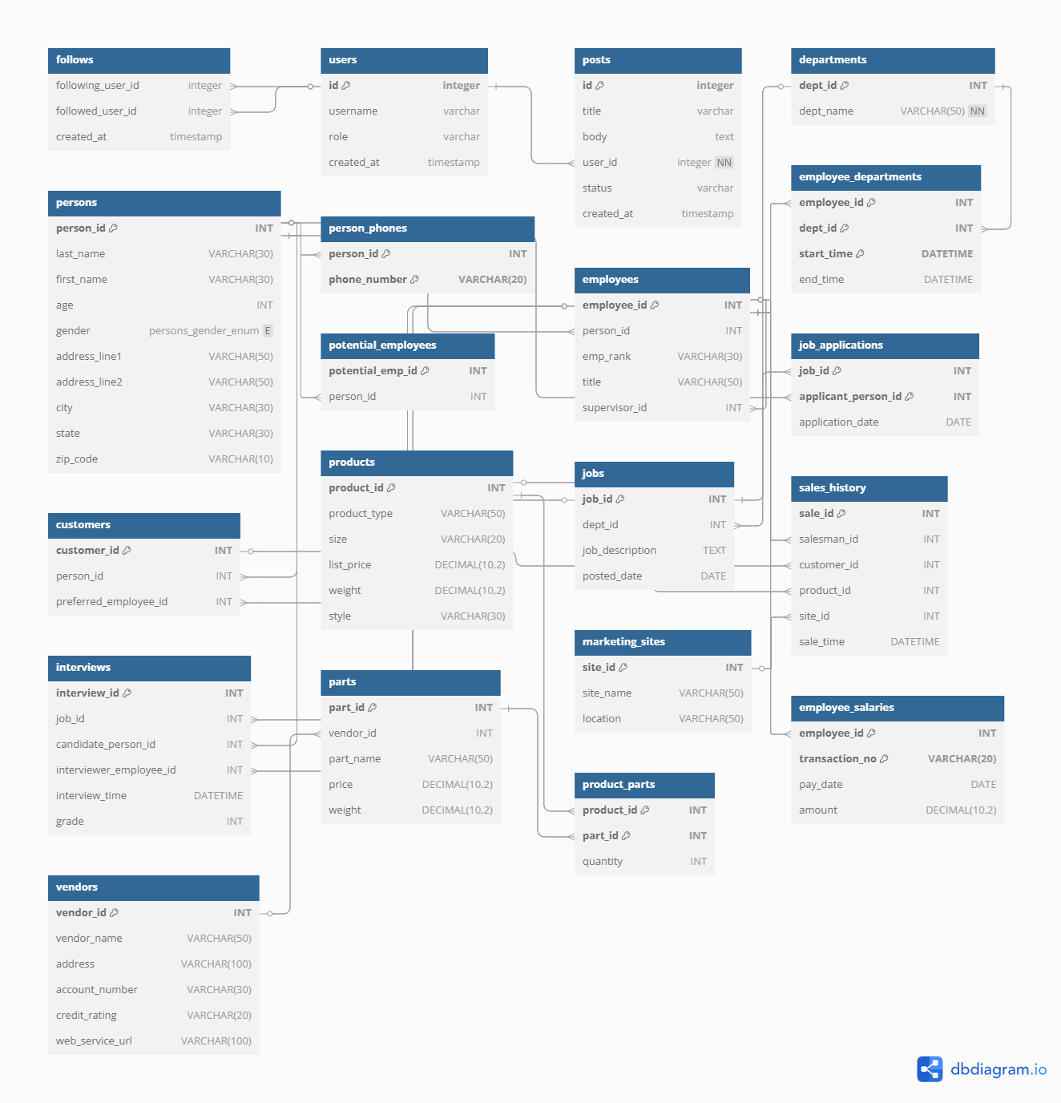
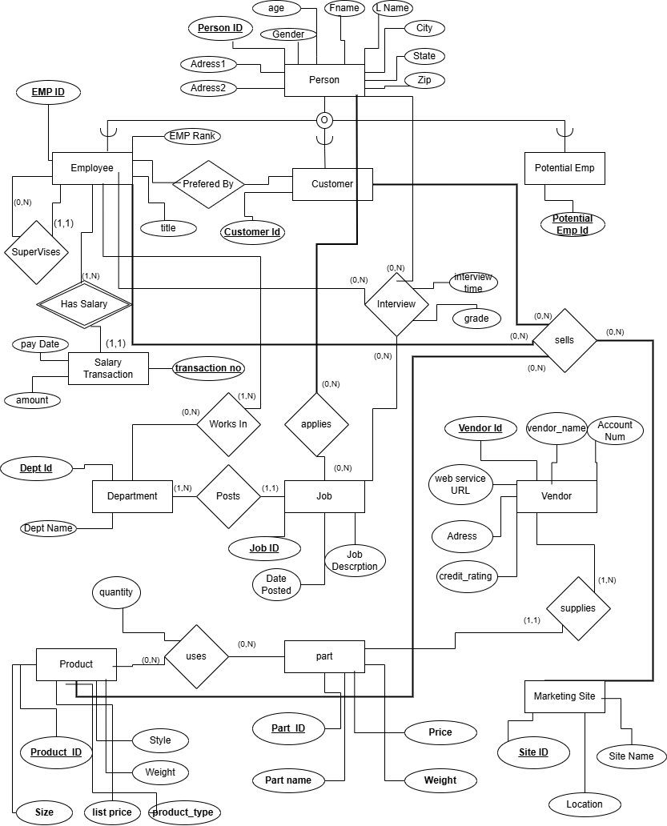

Relation schema after normalization
Department(
dept_id PK,
dept_name
)

Person(
person_id PK,
last_name,
first_name,
age,
gender,
address_line1,
address_line2,
city,
state,
zip_code
)

PersonPhones(
person_id FK→Person(person_id),
phone_number PK
)

Employee(
employee_id PK,
person_id FK→Person(person_id),
emp_rank,
title,
supervisor_id FK→Employee(employee_id)
)

EmployeeDepartments(
employee_id FK→Employee(employee_id),
dept_id FK→Department(dept_id),
start_time PK,
end_time
)

Customer(
customer_id PK,
person_id FK→Person(person_id),
preferred_employee_id FK→Employee(employee_id)
)

PotentialEmployee(
potential_emp_id PK,
person_id FK→Person(person_id)
)

Job(
job_id PK,
dept_id FK→Department(dept_id),
job_description,
posted_date
)

JobApplications(
job_id FK→Job(job_id),
applicant_person_id FK→Person(person_id),
application_date,
PK(job_id, applicant_person_id)
)

Interview(
interview_id PK,
job_id FK→Job(job_id),
candidate_person_id FK→Person(person_id),
interviewer_employee_id FK→Employee(employee_id),
interview_time,
grade
)

Product(
product_id PK,
product_type,
size,
list_price,
weight,
style
)

MarketingSite(
site_id PK,
site_name,
location
)

SalesHistory(
sale_id PK,
salesman_id FK→Employee(employee_id),
customer_id FK→Customer(customer_id),
product_id FK→Product(product_id),
site_id FK→MarketingSite(site_id),
sale_time
)

Vendor(
vendor_id PK,
vendor_name,
address,
account_number,
credit_rating,
web_service_url
)

Part(
part_id PK,
vendor_id FK→Vendor(vendor_id),
part_name,
price,
weight
)

ProductParts(
product_id FK→Product(product_id),
part_id FK→Part(part_id),
quantity,
PK(product_id, part_id)
)

EmployeeSalaries(
employee_id FK→Employee(employee_id),
transaction_no PK component,
pay_date,
amount,
PK(employee_id, transaction_no)
)

Dependency Diagram:
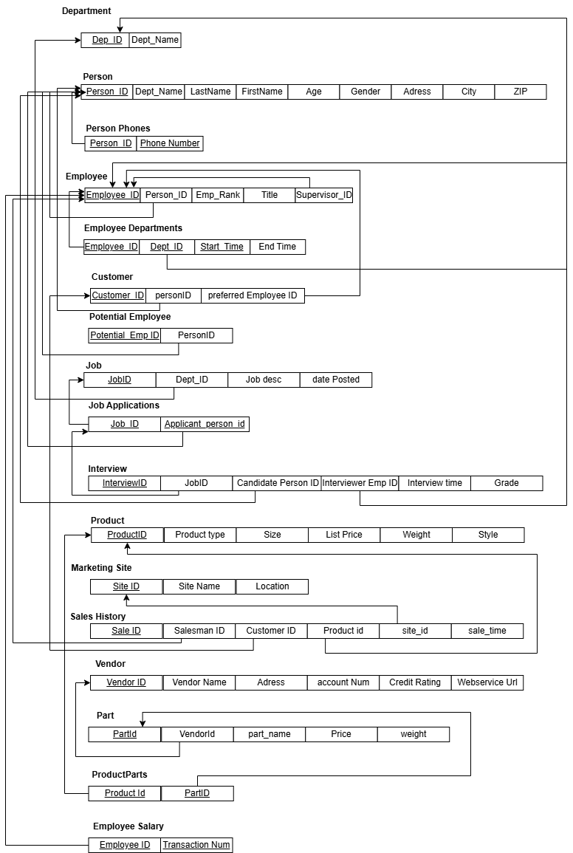

SQL Statements:
-- departments
CREATE TABLE departments (
dept_id INT PRIMARY KEY,
dept_name VARCHAR(50) NOT NULL
);

-- persons
CREATE TABLE persons (
person_id INT PRIMARY KEY,
last_name VARCHAR(30),
first_name VARCHAR(30),
age INT CHECK(age < 65),
gender ENUM('M', 'F', 'Other'),
address_line1 VARCHAR(50),
address_line2 VARCHAR(50),
city VARCHAR(30),
state VARCHAR(30),
zip_code VARCHAR(10)
);

ALTER TABLE persons
ADD COLUMN email VARCHAR(100);

-- person_phones
CREATE TABLE person_phones (
person_id INT,
phone_number VARCHAR(20),
PRIMARY KEY (person_id, phone_number),
FOREIGN KEY (person_id) REFERENCES persons(person_id)
);

-- employees
CREATE TABLE employees (
employee_id INT PRIMARY KEY,
person_id INT UNIQUE,
emp_rank VARCHAR(30),
title VARCHAR(50),
supervisor_id INT,
FOREIGN KEY (person_id) REFERENCES persons(person_id),
FOREIGN KEY (supervisor_id) REFERENCES employees(employee_id)
);

-- employee_departments
CREATE TABLE employee_departments (
employee_id INT,
dept_id INT,
start_time DATETIME,
end_time DATETIME,
PRIMARY KEY (employee_id, dept_id, start_time),
FOREIGN KEY (employee_id) REFERENCES employees(employee_id),
FOREIGN KEY (dept_id) REFERENCES departments(dept_id)
);

-- customers
CREATE TABLE customers (
customer_id INT PRIMARY KEY,
person_id INT UNIQUE,
preferred_employee_id INT,
FOREIGN KEY (person_id) REFERENCES persons(person_id),
FOREIGN KEY (preferred_employee_id) REFERENCES employees(employee_id)
);

-- potential_employees
CREATE TABLE potential_employees (
potential_emp_id INT PRIMARY KEY,
person_id INT UNIQUE,
FOREIGN KEY (person_id) REFERENCES persons(person_id)
);

-- jobs
CREATE TABLE jobs (
job_id INT PRIMARY KEY,
dept_id INT,
job_description TEXT,
posted_date DATE,
FOREIGN KEY (dept_id) REFERENCES departments(dept_id)
);

-- job_applications
CREATE TABLE job_applications (
job_id INT,
applicant_person_id INT,
application_date DATE,
PRIMARY KEY (job_id, applicant_person_id),
FOREIGN KEY (job_id) REFERENCES jobs(job_id),
FOREIGN KEY (applicant_person_id) REFERENCES persons(person_id)
);

-- interviews
CREATE TABLE interviews (
interview_id INT AUTO_INCREMENT PRIMARY KEY,
job_id INT,
candidate_person_id INT,
interviewer_employee_id INT,
interview_time DATETIME,
grade INT CHECK(grade BETWEEN 0 AND 100),
FOREIGN KEY (job_id) REFERENCES jobs(job_id),
FOREIGN KEY (candidate_person_id) REFERENCES persons(person_id),
FOREIGN KEY (interviewer_employee_id) REFERENCES employees(employee_id)
);

-- products
CREATE TABLE products (
product_id INT PRIMARY KEY,
product_type VARCHAR(50),
size VARCHAR(20),
list_price DECIMAL(10,2),
weight DECIMAL(10,2),
style VARCHAR(30)
);

-- marketing_sites
CREATE TABLE marketing_sites (
site_id INT PRIMARY KEY,
site_name VARCHAR(50),
location VARCHAR(50)
);

-- sales_history
CREATE TABLE sales_history (
sale_id INT AUTO_INCREMENT PRIMARY KEY,
salesman_id INT,
customer_id INT,
product_id INT,
site_id INT,
sale_time DATETIME,
FOREIGN KEY (salesman_id) REFERENCES employees(employee_id),
FOREIGN KEY (customer_id) REFERENCES customers(customer_id),
FOREIGN KEY (product_id) REFERENCES products(product_id),
FOREIGN KEY (site_id) REFERENCES marketing_sites(site_id)
);

-- vendors
CREATE TABLE vendors (
vendor_id INT PRIMARY KEY,
vendor_name VARCHAR(50),
address VARCHAR(100),
account_number VARCHAR(30),
credit_rating VARCHAR(20),
web_service_url VARCHAR(100)
);

-- parts
CREATE TABLE parts (
part_id INT PRIMARY KEY,
vendor_id INT,
part_name VARCHAR(50),
price DECIMAL(10,2),
weight DECIMAL(10,2),
FOREIGN KEY (vendor_id) REFERENCES vendors(vendor_id)
);

-- product_parts
CREATE TABLE product_parts (
product_id INT,
part_id INT,
quantity INT,
PRIMARY KEY (product_id, part_id),
FOREIGN KEY (product_id) REFERENCES products(product_id),
FOREIGN KEY (part_id) REFERENCES parts(part_id)
);

-- employee_salaries
CREATE TABLE employee_salaries (
employee_id INT,
transaction_no VARCHAR(20),
pay_date DATE,
amount DECIMAL(10,2),
PRIMARY KEY (employee_id, transaction_no),
FOREIGN KEY (employee_id) REFERENCES employees(employee_id)
);

Create VIEW Statements:
-- 1) Average monthly salary per employee
CREATE VIEW avg_monthly_salary AS
SELECT
employee_id,
DATE_FORMAT(pay_date, '%Y-%m') AS month_year,
ROUND(AVG(amount), 2) AS avg_salary
FROM employee_salaries
GROUP BY employee_id, month_year;

-- 2) Number of passed interview rounds for each interviewee and job
CREATE VIEW interview_pass_count AS
SELECT
candidate_person_id AS person_id,
job_id,
COUNT(*) AS passed_rounds
FROM interviews
WHERE grade > 60
GROUP BY candidate_person_id, job_id;

-- 3) Total items sold by product type
CREATE VIEW items_sold_per_type AS
SELECT
p.product_type,
COUNT(*) AS total_sold
FROM sales_history s
JOIN products p USING (product_id)
GROUP BY p.product_type;

-- 4) Total part purchase cost per product
CREATE VIEW part_purchase_cost AS
SELECT
pp.product_id,
ROUND(SUM(pp.quantity * pr.price), 2) AS total_part_cost
FROM product_parts pp
JOIN parts pr USING (part_id)
GROUP BY pp.product_id;
Answering The Queries:
-- Query 1: Interviewers for candidate Hellen Cole in job 11111
SELECT DISTINCT
e.employee_id,
CONCAT(p2.first_name, ' ', p2.last_name) AS interviewer_name
FROM interviews AS i
JOIN persons AS p1 ON i.candidate_person_id = p1.person_id
JOIN employees AS e ON i.interviewer_employee_id = e.employee_id
JOIN persons AS p2 ON e.person_id = p2.person_id
WHERE p1.first_name = 'Hellen'
AND p1.last_name = 'Cole'
AND i.job_id = 11111;

-- Query 2: IDs of jobs posted by Marketing in January 2011
SELECT j.job_id
FROM jobs AS j
JOIN departments AS d ON j.dept_id = d.dept_id
WHERE d.dept_name = 'Marketing'
AND j.posted_date BETWEEN '2011-01-01' AND '2011-01-31';

-- Query 3: Employees with no supervisees
SELECT
e.employee_id,
CONCAT(p.first_name, ' ', p.last_name) AS employee_name
FROM employees AS e
JOIN persons AS p ON e.person_id = p.person_id
WHERE e.employee_id NOT IN (
SELECT supervisor_id
FROM employees
WHERE supervisor_id IS NOT NULL
);

-- Query 4: Marketing sites with no sales in March 2011
SELECT
ms.site_id,
ms.location
FROM marketing_sites AS ms
WHERE ms.site_id NOT IN (
SELECT site_id
FROM sales_history
WHERE sale_time BETWEEN '2011-03-01' AND '2011-03-31'
);

-- Query 5: Jobs without a suitable hire one month after posting
SELECT
j.job_id,
j.job_description
FROM jobs AS j
WHERE j.job_id NOT IN (
SELECT i.job_id
FROM interviews AS i
GROUP BY i.job_id, i.candidate_person_id
HAVING AVG(i.grade) > 70
AND SUM(i.grade > 60) >= 5
);

-- Query 6: Salesmen who sold every product priced over $200
SELECT
e.employee_id,
CONCAT(p.first_name, ' ', p.last_name) AS salesman_name
FROM employees AS e
JOIN persons AS p ON e.person_id = p.person_id
WHERE NOT EXISTS (
SELECT 1
FROM products AS pr
WHERE pr.list_price > 200
AND NOT EXISTS (
SELECT 1
FROM sales_history AS s
WHERE s.salesman_id = e.employee_id
AND s.product_id = pr.product_id
)
);

-- Query 7: Departments with no job posts between 2011-01-01 and 2011-02-01
SELECT
d.dept_id,
d.dept_name
FROM departments AS d
WHERE d.dept_id NOT IN (
SELECT dept_id
FROM jobs
WHERE posted_date BETWEEN '2011-01-01' AND '2011-02-01'
);

-- Query 8: Employees who applied for job 12345 and are currently assigned
SELECT
e.employee_id,
CONCAT(p.first_name, ' ', p.last_name) AS employee_name,
ed.dept_id
FROM employees AS e
JOIN persons AS p ON e.person_id = p.person_id
JOIN job_applications AS ja ON ja.applicant_person_id = e.person_id
JOIN employee_departments AS ed
ON ed.employee_id = e.employee_id
AND ed.end_time IS NULL
WHERE ja.job_id = 12345;

-- Query 9: Best-selling product type
SELECT x.product_type
FROM (
SELECT
p.product_type,
COUNT(*) AS sold_count
FROM sales_history AS s
JOIN products AS p ON s.product_id = p.product_id
GROUP BY p.product_type
) AS x
ORDER BY x.sold_count DESC
LIMIT 1;

-- Query 10: Product type with highest net profit (revenue - cost)
SELECT
p.product_type
FROM products AS p
JOIN (
SELECT
s.product_id,
SUM(pr.list_price) AS total_revenue
FROM sales_history AS s
JOIN products AS pr ON s.product_id = pr.product_id
GROUP BY s.product_id
) AS rev ON rev.product_id = p.product_id
JOIN (
SELECT
pp.product_id,
SUM(pp.quantity * pa.price) AS total_cost
FROM product_parts AS pp
JOIN parts AS pa ON pp.part_id = pa.part_id
GROUP BY pp.product_id
) AS cost ON cost.product_id = p.product_id
ORDER BY (rev.total_revenue - cost.total_cost) DESC
LIMIT 1;

-- Query 11: Employees who have worked in all departments
SELECT
e.employee_id,
CONCAT(p.first_name, ' ', p.last_name) AS employee_name
FROM employees AS e
JOIN persons AS p ON e.person_id = p.person_id
WHERE NOT EXISTS (
SELECT 1
FROM departments AS d
WHERE NOT EXISTS (
SELECT 1
FROM employee_departments AS ed
WHERE ed.employee_id = e.employee_id
AND ed.dept_id = d.dept_id
)
);

-- Query 12: Names and emails of selected interviewees
SELECT
CONCAT(p.first_name, ' ', p.last_name) AS interviewee_name,
p.email
FROM persons AS p
WHERE p.person_id IN (
SELECT i.candidate_person_id
FROM interviews AS i
GROUP BY i.candidate_person_id
HAVING AVG(i.grade) > 70
AND SUM(i.grade > 60) >= 5
);

-- Query 13: Contact info for interviewees selected for all applied jobs
SELECT DISTINCT
CONCAT(p.first_name, ' ', p.last_name) AS interviewee_name,
ph.phone_number
FROM job_applications AS ja
JOIN interviews AS i
ON ja.applicant_person_id = i.candidate_person_id
AND ja.job_id = i.job_id
JOIN persons AS p
ON p.person_id = ja.applicant_person_id
JOIN person_phones AS ph
ON ph.person_id = p.person_id
GROUP BY p.person_id, ph.phone_number
HAVING AVG(i.grade) > 70
AND SUM(i.grade > 60) >= 5;

-- Query 14: Employee with highest average monthly salary
SELECT
e.employee_id,
CONCAT(p.first_name, ' ', p.last_name) AS employee_name
FROM avg_monthly_salary AS v
JOIN employees AS e ON v.employee_id = e.employee_id
JOIN persons AS p ON e.person_id = p.person_id
ORDER BY v.avg_salary DESC
LIMIT 1;

-- Query 15: Vendor offering 'Cup' part under 4 lbs at lowest price
SELECT
v.vendor_id,
v.vendor_name
FROM parts AS pr
JOIN vendors AS v ON pr.vendor_id = v.vendor_id
WHERE pr.part_name = 'Cup'
AND pr.weight < 4
AND pr.price = (
SELECT MIN(price)
FROM parts
WHERE part_name = 'Cup'
AND weight < 4
);

